


GovAssure:
Scoping Document

Completion Details
Government Department
Document owner
Date of completion
Document authorised by
Date authorised

Purpose of this document?
The purpose of this document is to record key discussions and decisions taken by the organisations to identify and define their essential services and ‘in-scope’ critical systems for GovAssure. This document will provide an evidence-based justification of the scope of GovAssure for organisations.

Stage 1:Organisational Context & Services
Part A: Context, Background, Threat Landscape and Risk Appetite
Part B: Identifying and Defining the Essential Services

Stage 2: In-Scope Systems & Alignment to CAF Profile
Part A: Identifying and Defining the Critical Systems
Part B: In-Scope Critical Systems for GovAssure and Assigning the Target CAF Profile

Who is this document for?
This document is primarily for use by the relevant government organisation and the organisation’s service and system owners, as well as Government Security Group (GSG) who will agree the scope of GovAssure. This document will be routinely referred to throughout the end-to-end GovAssure process. It will also be used as part of Stage 4: Independent Assurance Review of GovAssure (see stages of GovAssure on page 3) the following page

How to use this document?
This document will be completed by organisations and shared with GSG as part of scoping discussions. Once agreed, this will be shared with Independent Assurance Providers to support the Assurance Reviews. It will not be shared more widely unless agreed.
Key roles and responsibilities
GovAssure Accountable Officer
GovAssure Coordinator / Responsible Officer

GovAssure stages summary and use of this Scoping Document

GovAssure consists of five main stages – this document should be completed for Stage 1 and 2 of GovAssure:
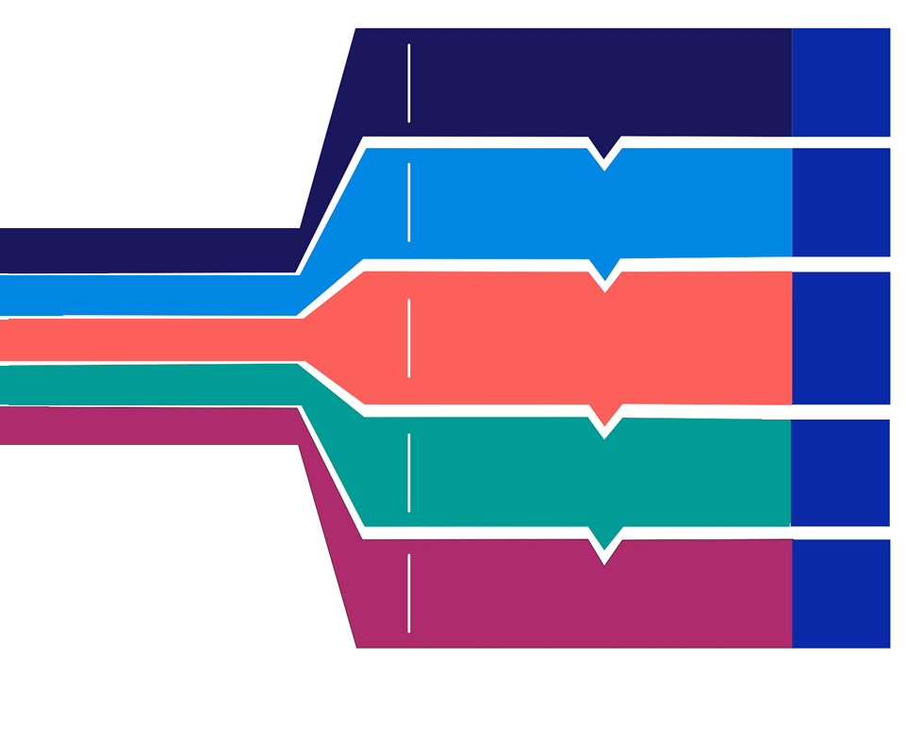
02
03
04
05
Understanding the context and overall mission of the organisation to identify essential services. These will help shape and scope the GovAssure self-assessment.
Identifying and prioritising the systems on which essential services rely and considering the system boundaries and determining the dependencies. Identifying the CAF profile (Baseline or Enhanced) to be assigned.
Owner:
Department
01
Stage 1: Organisational Context & Services
Stage 2: In-Scope Systems & Alignment to the CAF Profile
Stage 3: CAF Self-Assessment
Owner:
Department & GSG
Owner:
Department & GSG
Owner:
Independent Assessor,
Department & GSG
Owner:
Independent Assessor,
Department & GSG
Stage 4: Independent Assurance Review
Stage 5: Final Assessment & Targeted Improvement Plan
Understanding the context and overall mission of the organisation to identify essential services. These will help shape and scope the GovAssure self-assessment.
02
03
04
05
Self-assessment will be reviewed by an independent assessor, providing independent and objective verification of the assessment. Assessors will meet the minimum security and assurance requirements.
A final report will be produced, outlining observations and recommendations and providing assessment against the target CAF profile. This will be a key mechanism to support investment and decision making.
Owner:
Department
Identifying and prioritising the systems on which essential services rely and considering the system boundaries and determining the dependencies. Identifying the CAF profile (Baseline or Enhanced) to be assigned.
Completion of a self-assessment for each organisation based on the scope identified during Stages 1 & 2 against the CAF Guidance documentation.

STAGE 1 - PART A: ORGANISATIONAL MISSION, OBJECTIVES AND PRIORITIES
Please consider and document the following ‘about the organisation’ aspects to help inform the organisational context that is presented to the independent assurance provider (Stage 4). Please keep all answers under 250 words.
Strategic Context | What are you fundamentally trying to achieve as an organisation? What is the organisation’s mission, objectives and priorities, and how does it support the delivery of Government services?  When answering, please think about how you would deliver an ‘elevator pitch’ about your organisation in 2-3 sentences.  - Mission:  - Objectives:  - Priorities:
Organisation background | How are you currently set up to deliver your mission / objectives and strategy?  How does your organisation operate? For example, are you an organisation that has 24/7 x 365 services that are delivered online, or an offline non-transactional service?
Current threat landscape | Who is looking to attack you, why are you a target, and ‘what could go wrong’ if they were successful? If there is a multi-threat picture, please feel free to bullet point the different types. Feel free to reference threat assessments if you have them.
Cyber Risk appetite | Please confirm if your organisation has a Cyber Risk Appetite (or not), where it is defined, and what the level of appetite is. If this is already defined and documented, feel free to copy and paste into this box.

STAGE 1 - PART B: IDENTIFYING AND DEFINING THE ESSENTIAL SERVICES
Please describe the number of essential services that you intend to assess as part of the GovAssure process and describe the method that was followed to determine which services are essential to your mission. Insert more rows where necessary.
Do you already have a defined methodology in place for mapping essential services? Y/N
If yes, please describe at a high level the methodology followed.
Essential service high level reference | Function | Type (OES/CNI/Other) | In scope?
Example:  Essential Service 1 |  | Critical National Infrastrucure | In scope
 |  | Please select | Unconfirmed
 |  | Please select | Unconfirmed

STAGE 2 - PART A: IDENTIFYING AND DEFINING THE CRITICAL SYSTEMS
Having considered your prioritised essential services, please consider the critical systems that support the delivery of these.
Do you already have a defined methodology in place for identifying and prioritising essential systems? Y/N
If yes, please describe at a high level the methodology followed.
Critical system | Essential Service / Function this supports (from Stage 1: Part B) | Core IT infrastructure underpinning the service (e.g. Network/Cloud Provider) | Breakdown of backend systems/applications (where applicable) | In scope?
Example:  Critical system 1 |  |  | App 01 | Unconfirmed

Add or remove tables to correlate to the number of in-scope systems your organisation has selected.
STAGE 2 - PART B: IDENTIFYING THE IN-SCOPE CRITICAL SYSTEMS FOR GOVASSURE
IN-SCOPE SYSTEM 1 DESCRIPTION
System name: | What is the technical name for the system and/or what its commonly referred to?
Essential service and function this supports | A brief description of what the essential service relies on this system for.
Description – what does the system do and why do you consider it in scope for GovAssure: | This should be the system that the business owner would recognise by its support of a specific business process(es).
Breakdown of components (if appropriate)
Logical components that support the business services, e.g. O365, Desktop Infrastructure, Network Infrastructure etc.
Key dependencies
What are the key dependencies that enable delivery of the system and service?
System boundary (Top-level)
Map out interdependencies on other systems/suppliers/organisations

System Name | Interdependencies
Please state the rationale for each boundary

In Scope Systems Diagrams
Please include diagrammatic representations of your In Scope systems, clearly indicating the following:
- The critical components and/or assets (grouped if needed);
- the security boundary around the critical components and/or assets (system boundary);
- other, non-critical, components and assets which are within the system boundary and related interconnectivity (direct wired and wireless); and
- entry and exit points within the system boundary including data ingress and egress points.

Applying the target Baseline or Enhanced Profile
Baseline / Enhanced (select which one)
Comments and justification
Provide a brief summary of why you have decided to apply this profile to the system going through GovAssure.

IN-SCOPE SYSTEM 2 DESCRIPTION
System name:
Essential service and function this supports
Description – what does the system do and why do you consider it in scope for GovAssure:
Breakdown of components (if appropriate)
Key dependencies
System boundary (Top-level)
System Name | Interdependencies
Please state the rationale for each boundary

In Scope Systems Diagrams
Applying the target Baseline or Enhanced Profile
Baseline / Enhanced (select which one)
Comments and justification
Provide a brief summary of why you have decided to apply this profile to the system going through GovAssure.

IN-SCOPE SYSTEM 3 DESCRIPTION
System name:
Essential service and function this supports
Description – what does the system do and why do you consider it in scope for GovAssure:
Breakdown of components (if appropriate)
Key dependencies
System boundary (Top-level)
System Name | Interdependencies
Please state the rationale for each boundary

In Scope Systems Diagrams
Applying the target Baseline or Enhanced Profile
Baseline / Enhanced (select which one)
Comments and justification
Provide a brief summary of why you have decided to apply this profile to the system going through GovAssure.

IN-SCOPE SYSTEM 4 DESCRIPTION
System name:
Essential service and function this supports
Description – what does the system do and why do you consider it in scope for GovAssure:
Breakdown of components (if appropriate)
Key dependencies
System boundary (Top-level)
System Name | Interdependencies
Please state the rationale for each boundary

In Scope Systems Diagrams
Applying the target Baseline or Enhanced Profile
Baseline / Enhanced (select which one)
Comments and justification
Provide a brief summary of why you have decided to apply this profile to the system going through GovAssure.

IN-SCOPE SYSTEM 5 DESCRIPTION
System name:
Essential service and function this supports
Description – what does the system do and why do you consider it in scope for GovAssure:
Breakdown of components (if appropriate)
Key dependencies
System boundary (Top-level)
System Name | Interdependencies
Please state the rationale for each boundary

In Scope Systems Diagrams
Applying the target Baseline or Enhanced Profile
Baseline / Enhanced (select which one)
Comments and justification
Provide a brief summary of why you have decided to apply this profile to the system going through GovAssure.

IN-SCOPE SYSTEM 6 DESCRIPTION
System name:
Essential service and function this supports
Description – what does the system do and why do you consider it in scope for GovAssure:
Breakdown of components (if appropriate)
Key dependencies
System boundary (Top-level)
System Name | Interdependencies
Please state the rationale for each boundary

In Scope Systems Diagrams
Applying the target Baseline or Enhanced Profile
Baseline / Enhanced (select which one)
Comments and justification
Provide a brief summary of why you have decided to apply this profile to the system going through GovAssure.

IN-SCOPE SYSTEM 7 DESCRIPTION
System name:
Essential service and function this supports
Description – what does the system do and why do you consider it in scope for GovAssure:
Breakdown of components (if appropriate)
Key dependencies
System boundary (Top-level)
System Name | Interdependencies
Please state the rationale for each boundary

In Scope Systems Diagrams
Applying the target Baseline or Enhanced Profile
Baseline / Enhanced (select which one)
Comments and justification
Provide a brief summary of why you have decided to apply this profile to the system going through GovAssure.

IN-SCOPE SYSTEM 8 DESCRIPTION
System name:
Essential service and function this supports
Description – what does the system do and why do you consider it in scope for GovAssure:
Breakdown of components (if appropriate)
Key dependencies
System boundary (Top-level)
System Name | Interdependencies
Please state the rationale for each boundary

In Scope Systems Diagrams
Applying the target Baseline or Enhanced Profile
Baseline / Enhanced (select which one)
Comments and justification
Provide a brief summary of why you have decided to apply this profile to the system going through GovAssure.

